Manhwa (만화)

Definition
# Source: AI Source: Provided by: [Data Path: Persons Table -> ID Column: 1, Name_En Column: Motasem Essam] -> From: [ChatGPT] on [10/28/2025]
Manhwa is the Korean term for comics or graphic novels — just like “manga” in Japan or “manhua” in China.
So:
- 🇯🇵 Manga → Japanese comics
- 🇰🇷 Manhwa → Korean comics
- 🇨🇳 Manhua → Chinese comics

Key Features of Manhwa:
# Source: AI Source: Provided by: [Data Path: Persons Table -> ID Column: 1, Name_En Column: Motasem Essam] -> From: [ChatGPT] on [10/28/2025]
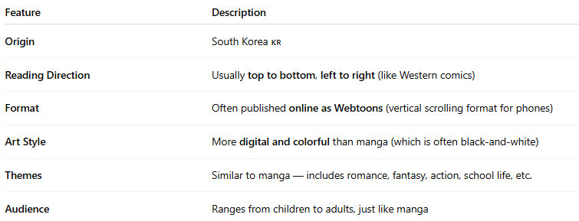
Feature | Description
Origin | South Korea 🇰🇷
Reading Direction | Usually top to bottom, left to right (like Western comics)
Format | Often published online as Webtoons (vertical scrolling format for phones)
Art Style | More digital and colorful than manga (which is often black-and-white)
Themes | Similar to manga — includes romance, fantasy, action, school life, etc.
Audience | Ranges from children to adults, just like manga

Famous Manhwa Examples:
# Source: AI Source: Provided by: [Data Path: Persons Table -> ID Column: 1, Name_En Column: Motasem Essam] -> From: [ChatGPT] on [10/28/2025]
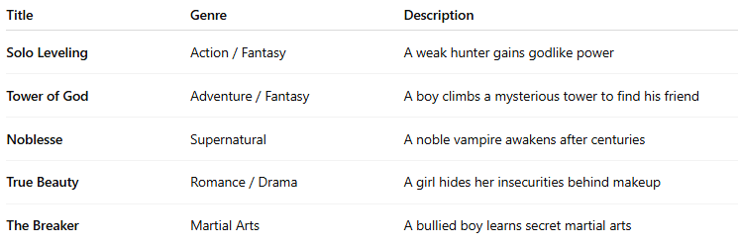
Title | Genre | Description
Solo Leveling | Action / Fantasy | A weak hunter gains godlike power
Tower of God | Adventure / Fantasy | A boy climbs a mysterious tower to find his friend
Noblesse | Supernatural | A noble vampire awakens after centuries
True Beauty | Romance / Drama | A girl hides her insecurities behind makeup
The Breaker | Martial Arts | A bullied boy learns secret martial arts

In Short:
# Source: AI Source: Provided by: [Data Path: Persons Table -> ID Column: 1, Name_En Column: Motasem Essam] -> From: [ChatGPT] on [10/28/2025]
🧠 Manhwa = Korean comics (often digital, colorful, and read vertically online).
The most popular platform for reading them is Webtoon.

